AdvanceSearch Plugin Development:

Folder structure:
Under Deploy Folder ,Plugin named folder will be there(Here AdvanceSearchPlugin),under this folder will have one more folder named same as Plugin Name(AdvanceSearchPlugin) which will contain compliled java files in sub folder as ”com” and one more subfolder named “resources” which will contain css,js and vtl.

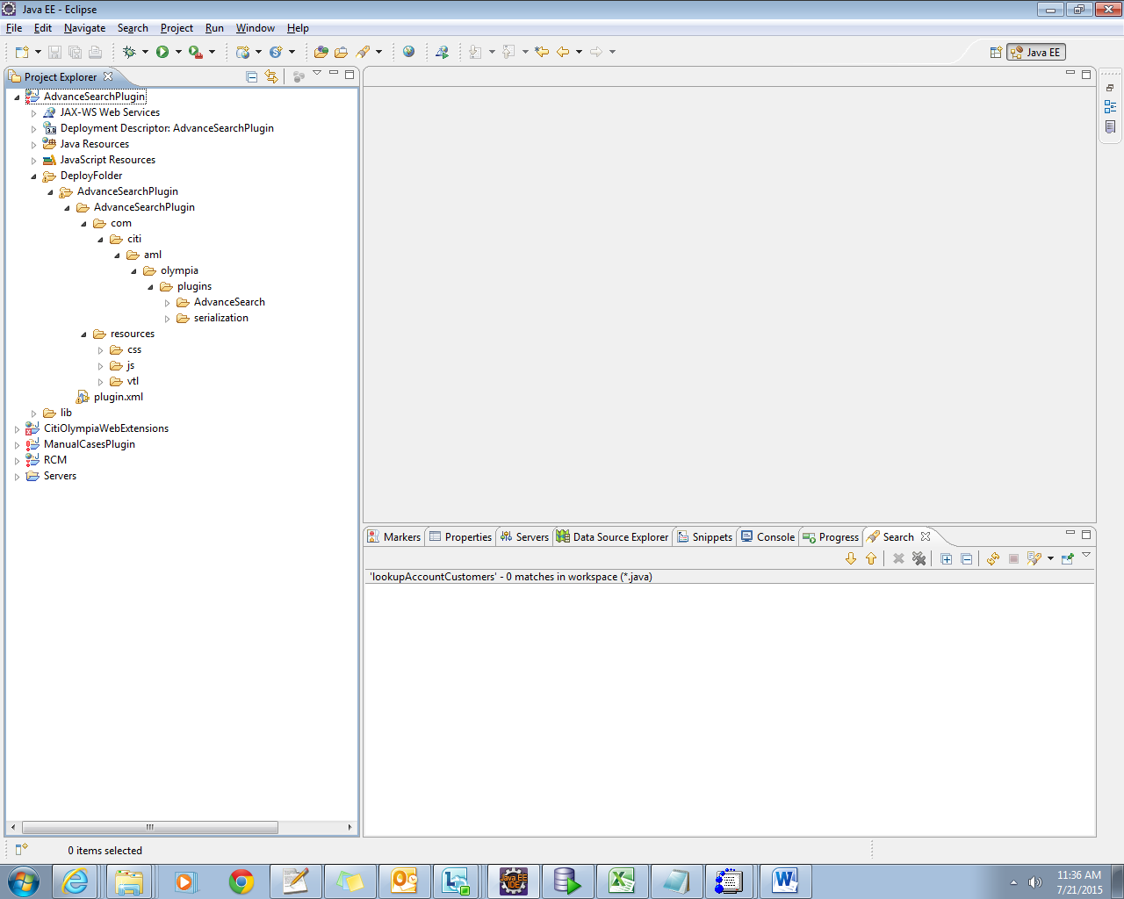

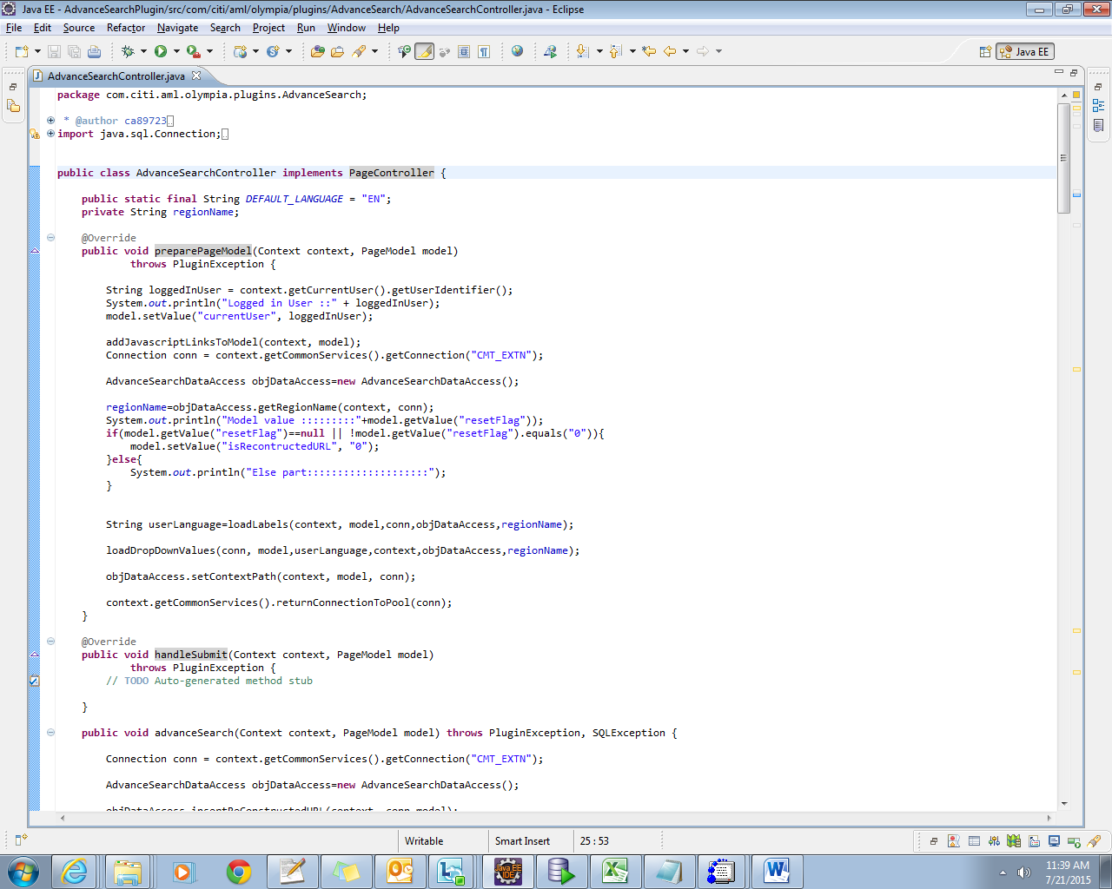

- Every controller should implement PageController interface and must implement the unimplemented methods (like preparePageModel(),getPageLocation())
public class AdvanceSearchController implements PageController {
//some code
}
- once the page is loaded on UI the below overridden method will be called in the below order
@Override
public void preparePageModel(Context context, PageModel model)
throws PluginException {
// some code
}
@Override
public String getPageLocation(Context context) {

if(regionName.equalsIgnoreCase("NAM-Hub"))
return "resources/vtl/AdvanceSearchPage_NAM.vtl";
else if(regionName.equalsIgnoreCase("EMEA-Hub"))
return "resources/vtl/AdvanceSearchPage_EMEA.vtl";

return null;
}
VTL returned from the above method will be automatically rendered in the UI.

AdvanceSearchPage_EMEA.vtl
Once we click on search button,the fillParametersAndSubmit() will be called
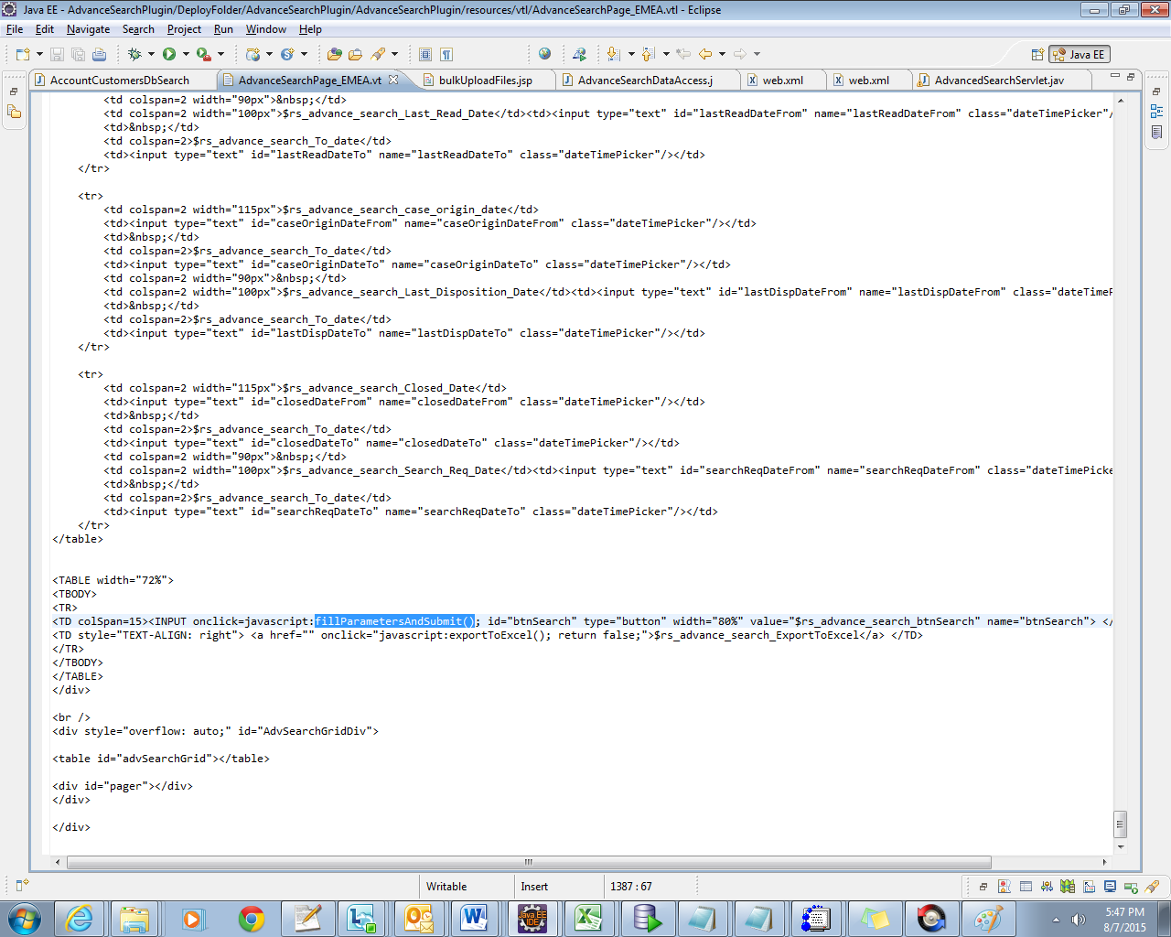
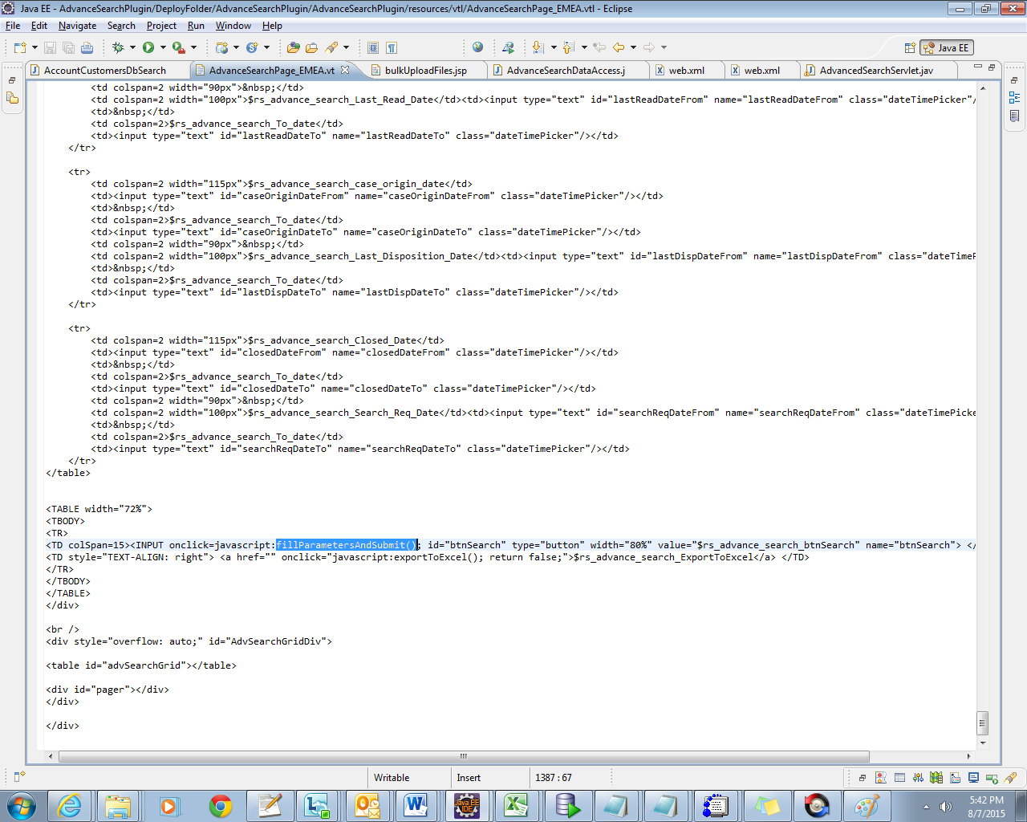
setPluginParameter() will set the values for the user input will be rendered to the controller through an action method

performPluginControllerAction('advanceSearch');
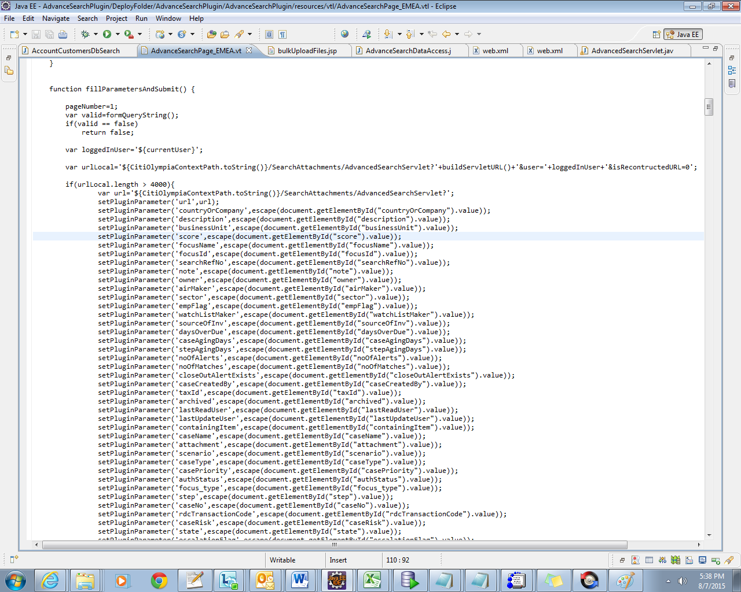
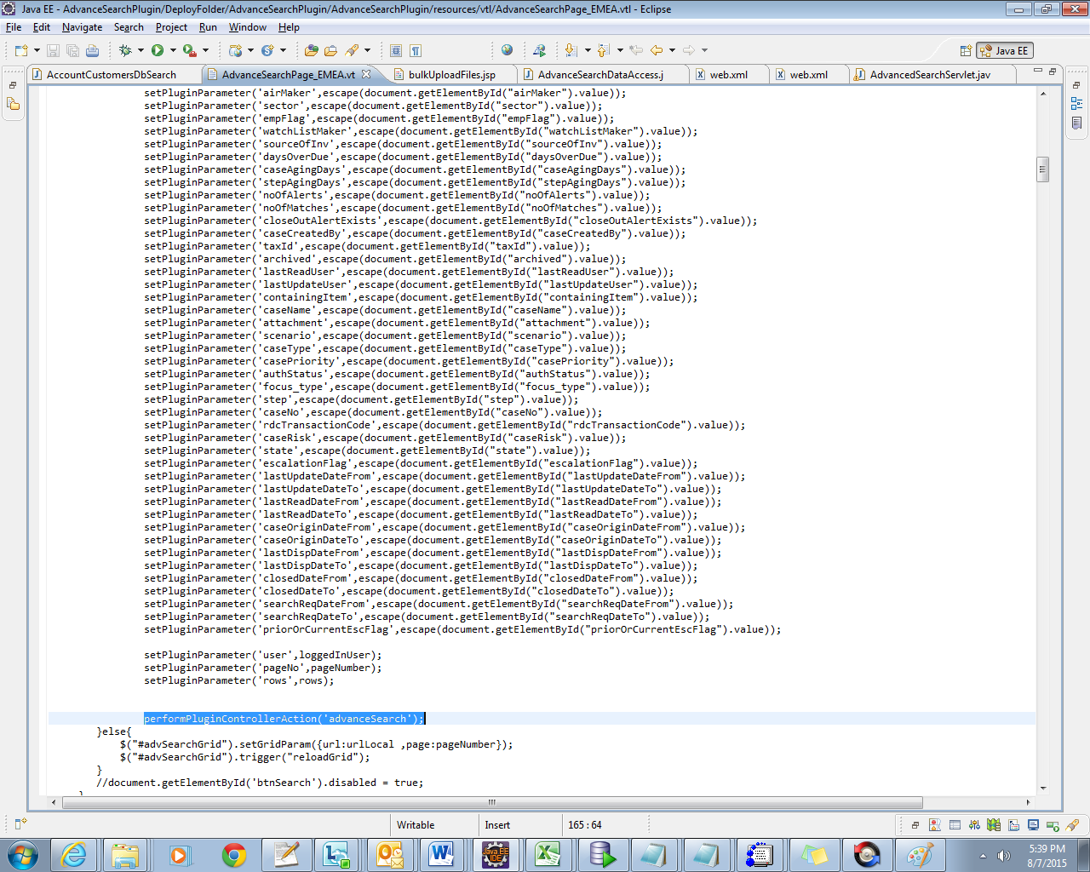
performPluginControllerAction('advanceSearch');
The above method will be performing some action based on the given id and this id should be described in “plugin.xml”.(see below plugin.xml for reference)

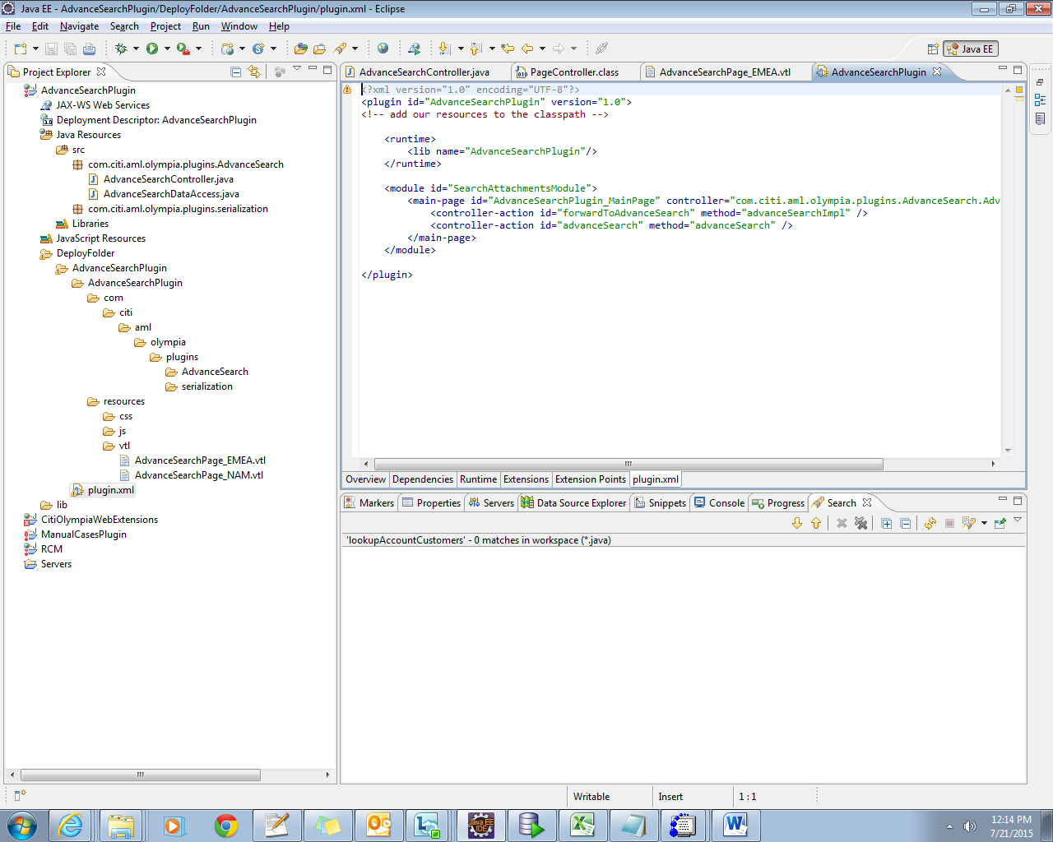
<module id="SearchAttachmentsModule">
<main-page id="AdvanceSearchPlugin_MainPage" controller="com.citi.aml.olympia.plugins.AdvanceSearch.AdvanceSearchController">
<controller-action id="advanceSearch" method="advanceSearch" />
</main-page>
</module>
**In the above code, based on the id from vtl, the controller will be called. For example here for id advanceSearch , AdvanceSearch.AdvanceSearchController is called and the advanceSearch() is invoked.**

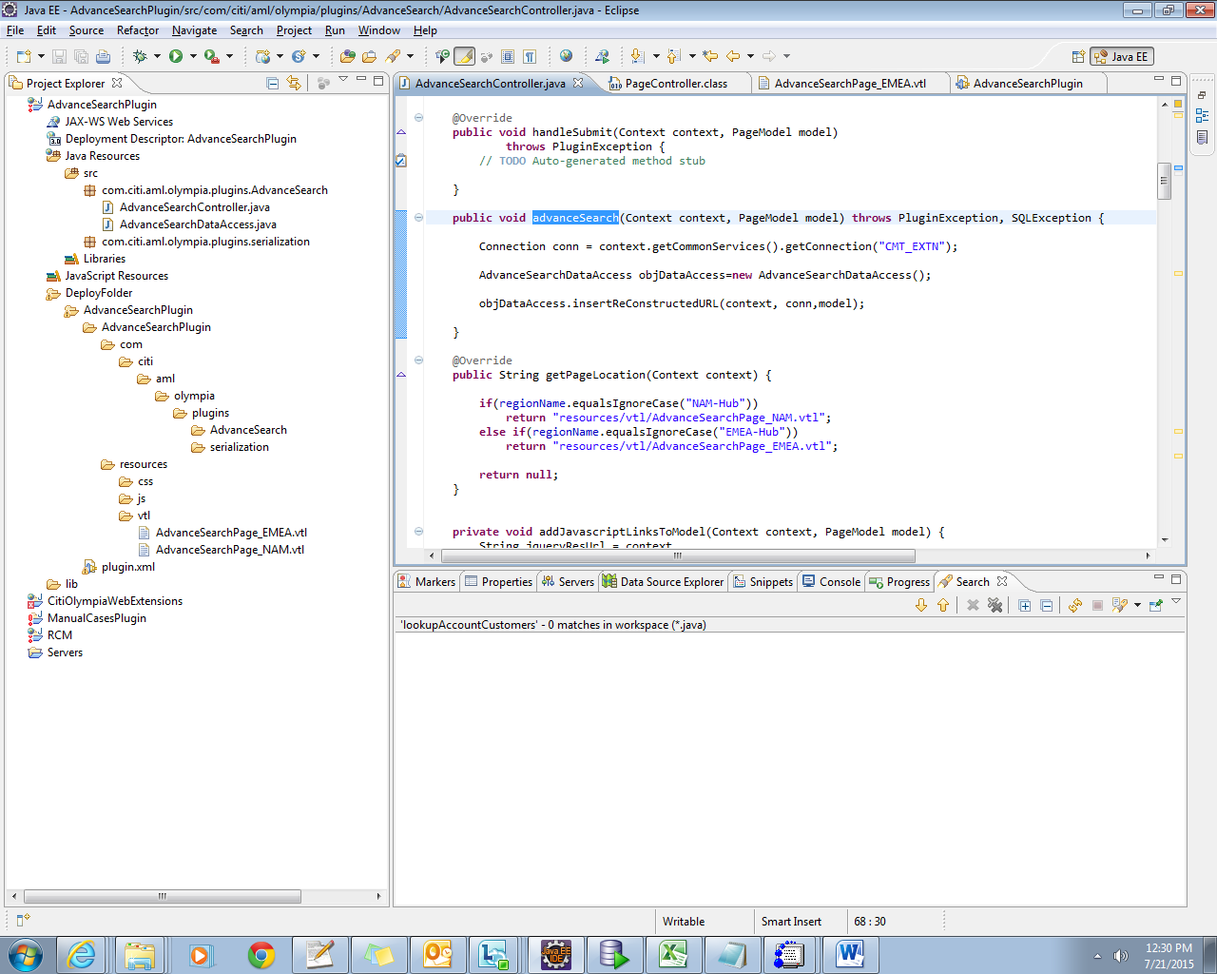

For labels and dropdown values the below mentioned tabled are used.
Parent table:resource_strings-----used to store resource strings of the fields in english
Child table:resource_strings_translation---this table will store resource strings in different languages.

Invoking the Servlet:
Here through vtl, we are calling post method of AdvancedSearchServlet specified in URL
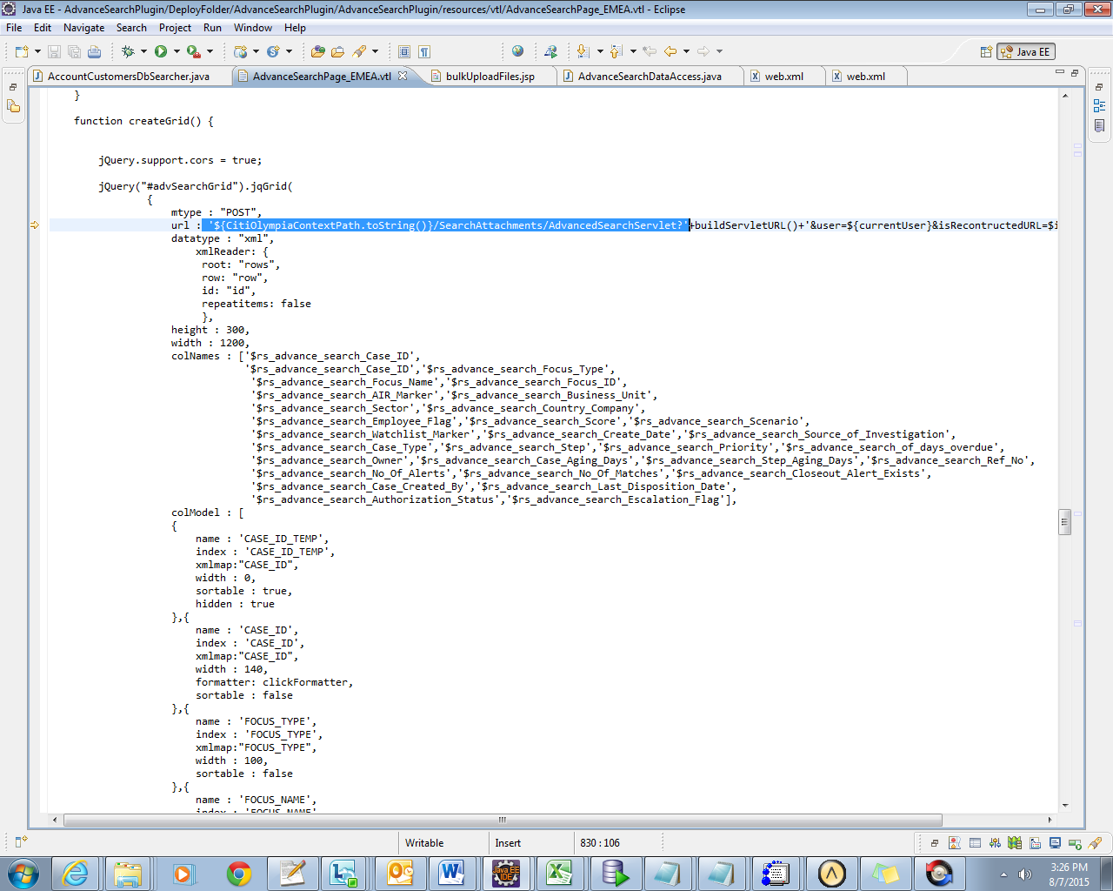

Web.xml
It contains servlet information.
<servlet>
<description>A servlet that receives Advanced Search requests and return the results</description>
<display-name>AdvancedSearchServlet</display-name>
<servlet-name>AdvancedSearchServlet</servlet-name>
<servlet-class>com.exzac.servlets.AdvancedSearchServlet</servlet-class>
</servlet>

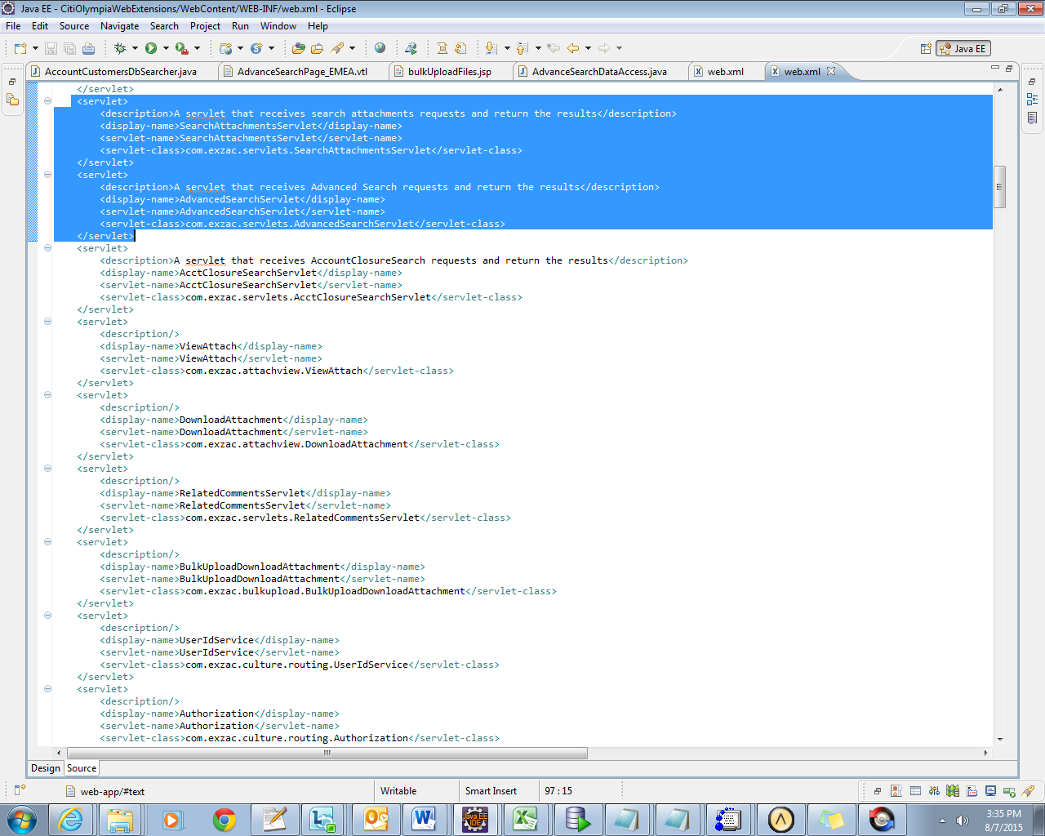

AdvancedSearchServlet.java

